INFORMATION AND COMMUNICATION TECONOLOGY

Project Name :-
Riders website.
Made by :-
- Muhammad Ateeb-ur-Rehman
- Qamar-ud-Din
- Khansa Javed
- Areeba Shahzadi
Class :-
BSCS-1A
Submitted to :-
Syed Hussain Ali Shah Gillani

WELCOME RIDERS
History of motorcycle :-
The invention of the motorcycle is generally credited to Gottlieb Daimler and Wilhelm Maybach in 1885. They built the first true motorcycle, called the Reitwagen, in Germany. This vehicle was powered by a gasoline engine and featured two wheels, making it the first motorized two-wheeled vehicle that resembled the motorcycles we know today.

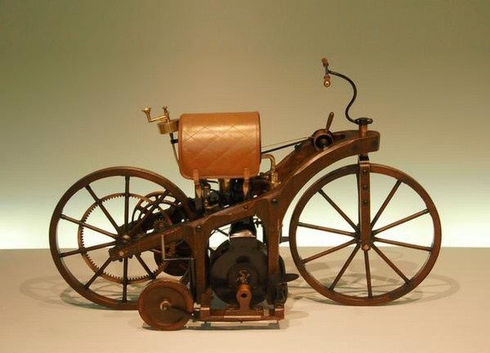

World-famous and trusted companies for bikes

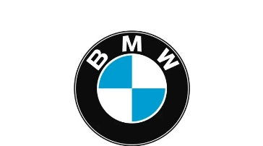
BMW
Bayerische Motoren Werke AG, trading as BMW Group, is a German multinational manufacturer of luxury vehicles and motorcycles headquartered in Munich, Bavaria, Germany.


DUCATI
Ducati Motor Holding S.p.A is an Italian motorcycle manufacturing company headquartered in Bologna, Italy. The company is directly owned by Italian automotive manufacturer Lamborghini, whose German parent company is Audi, itself owned by the Volkswagen Group.


KTM
KTM is an Austrian motorcycle, bicycle and motorsports brand which is co-owned by Indian manufacturer Bajaj Auto and Austrian manufacturer Pierer Mobility AG. It traces its foundation in 1934 as Kronreif & Trunkenpolz Mattighofen.


SUZAKI
Suzuki Motor Corporation is a Japanese multinational mobility manufacturer headquartered in Hamamatsu, Shizuoka. It manufactures automobiles, motorcycles, all-terrain vehicles, outboard marine engines, wheelchairs and a variety of other small internal combustion engines.


TRIUMPH
Triumph Motorcycles Ltd is the largest UK-owned motorcycle manufacturer, established in 1983 by John Bloor after the original company Triumph Engineering went into receivership. The new company, initially called Bonneville Coventry Ltd, continued Triumph's lineage of motorcycle production since 1902
(BMW)

S 1000 RR

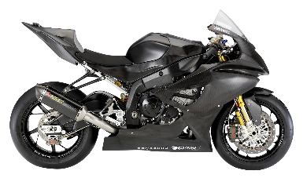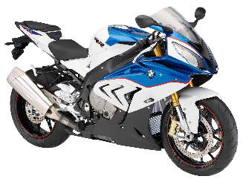

Name :- BMW s 1000 rr
Invented :- 2008
Released :- 2009
CC :- 1000 CC engine
Seater :- 2 Seater
Petrol tank :- 16.5 liters
Average per liter :- 16 km per liter
Top speed :- 303 km/h
Gear :- Six speed gear box
Braking system :- dual 320mm disc brakes in the front and a single 220mm disc brake in the rear.
Price :- 12,600,000 rupees

F 900 xr
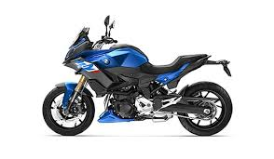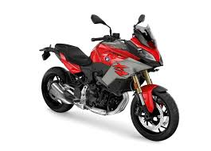
Name :- F 900 xr
Invented :- 2020
Released :- April 14, 2022
CC :- 895 CC engine
Seater :- 2 Seater
Petrol tank :- 15.5 liters
Average per liter :- 23.8 km per liter
Top speed :- 200 km/h
Gear :- 6-speed constant mesh gearbox
Braking system :- Font brake double disc brake
Rear break disc
Price :- 3,350,000 rupees

bmw k 1600 gtl
Name :- bmw k 1600 gtl
Invented :- 2010
Released :- April 14, 2014
CC :- 1649 CC engine
Seater :- 2 Seater
Petrol tank :- 26.5 liters
Average per liter :- 16.94 km per liter
Top speed :- 200 km/h
Gear :- 6-speed constant mesh gearbox
Braking system :- Font brake double disc brake
Rear break disc
Price :- 8,970,000 rupees

(DUCATI)

Multistrada v4
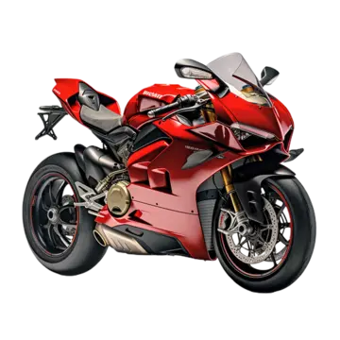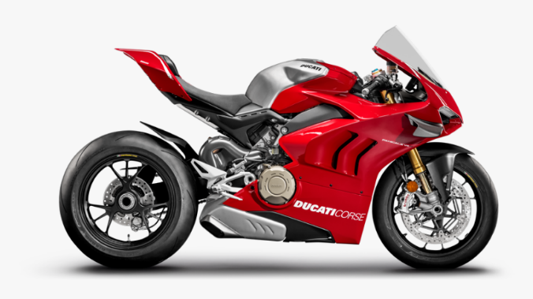
Name :- multistrada v4
Invented :- November 2021
Released :- September 2024
CC :- 1158 CC engine
Seater :- 2 Seater
Petrol tank :- 22 liters
Average per liter :- 15 km per liter
Top speed :- 250 km/h
Gear :- 6-speed manual, wet multi-plate clutch, chain final drive
Braking system :- Linked brakes
The 2025 Ducati Multistrada V4 S has updated linked brakes, where the rear lever can also operate the front brake.

Price :- 7,050,000 rupees

(scrambler ducati 10)
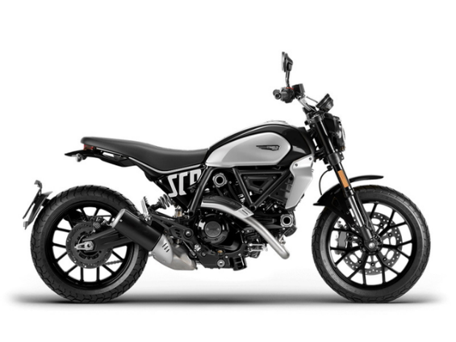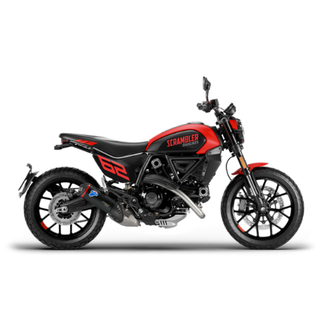

Name :- scrambler ducati 10
Invented :- september2024
Released :- October 17, 2024
CC :- 1079 CC engine
Seater :- 2 Seater
Petrol tank :- 13.5 liters
Average per liter :- 19 km per liter
Top speed :- 299 km/h
Gear :- 6-speed manual, wet multi-plate clutch, chain final drive
Braking system :- Disc brakes
Price :- 3,600,000 rupees

(DUCATI MONSTER)
Name :- Ducati monster
Invented :- september2000
Released :- October 17, 2002
CC :- 999CC engine
Seater :- 2 Seater
Petrol tank :- 14 liters
Average per liter :- 19 km per liter
Top speed :- 270 km/h
Gear :- 6-speed manual, wet multi-plate clutch, chain final drive
Braking system :- Disc brakes
Price :- 6.200,000 rupees

(KTM)

KTM RC-390

Name :- KTM RC-390
Invented :- september2000
Released :- October 17, 2002
CC :- 937 CC engine
Seater :- 2 Seater
Petrol tank :- 14 liters
Average per liter :- 19 km per liter
Top speed :- 299 km/h
Gear :- 6-speed manual, wet multi-plate clutch, chain final drive
Braking system :- Disc brakes
Price :- 7,600,000 rupees

KTM 200 DUKE

Name :- KTM 200-DUKE
Invented :- September 2012
Released :- October 16, 2014
CC :- 200 CC engine
Seater :- 2 Seater
Petrol tank :- 13.4 liters
Average per liter :- 35 km per liter
Top speed :- 142 km/h
Gear :- 6-Speed gear box
Braking system :- Disc brakes
Price :- 3,800,000 rupees

KTM RC-390

Name :- KTM RC-390
Invented :- September 2014
Released :- October 17, 2015
CC :- 390 CC engine
Seater :- 2 Seater
Petrol tank :- 13.7 liters
Average per liter :- 25.89 km per liter
Top speed :- 167 km/h
Gear :- 6-Speed gear box
Braking system :- Disc brakes
Price :- 3,900,000 rupees

(SUZUKI)
SUZUKI HAYABUSA

Name :- SUZUKI HAYABUSA
Invented :- 1998
Released :- 1999
CC :- 1340 CC engine
Seater :- 2 Seater
Petrol tank :- 20 liters
Average per liter :- 11 km per liter
Top speed :- 303 to 312 km/h
Gear :-6-speed, constant-mesh, close-ratio transmission
Braking system :- Disc brakes
Price :- 8,600,000 rupees

SUZUKI GIXXER-150

Name :- SUZUKI GIXXER-150
Invented :- September 2012
Released :- September 2014
CC :- 155 CC engine
Seater :- 2 Seater
Petrol tank :- 20 liters
Average per liter :- 45 km per liter
Top speed :- 132 km/h
Gear :- 5-speed gear system
Braking system :- Disc brakes
Price :- 600,000 rupees
SUZUKI V-STROM SX

Name :- SUZUKI V-STROM SX
Invented :- September 2002
Released :- September 2004
CC :- 250 CC engine
Seater :- 2 Seater
Petrol tank :- 12 liters
Average per liter :- 32 km per liter
Top speed :- 130 km/h
Gear :- six-speed constant mesh transmission
Braking system :- Disc brakes
Price :- 250,000 rupees

(TRIUMPH)
Triumph Trident 660

Name :- Triumph Trident 660
Invented :- January 2021
Released :- February 2004
CC :- 660 CC engine
Seater :- 2 Seater
Petrol tank :- 14 liters
Average per liter :- 22.88 km per liter
Top speed :- 212 km/h
Gear :- six-speed gear box
Braking system :- Disc brakes
Price :- 2,500,000 rupees
Triumph Scrambler 1200

Name :- Triumph Scrambler 1200
Invented :- 2019
Released :- January 2024
CC :- 1200 CC engine
Seater :- 2 Seater
Petrol tank :- 15 liters
Average per liter :- 24.6 km per liter
Top speed :- 370 km/h
Gear :- six-speed gear box
Braking system :- Disc brakes
Price :- 7,500,000 rupees

Triumph Street Triple 765

Name :- Triumph Street Triple 765
Invented :- 2007
Released :- January 2010
CC :- 1200 CC engine
Seater :- 2 Seater
Petrol tank :- 15 liters
Average per liter :- 29.2 km per liter
Top speed :- 220 km/h
Gear :- six-speed gear box
Braking system :- Disc brakes
Price :- 10,500,000 rupees

-: THE END :-

